

**Invitation**

**to our KS1 & KS2**

**Maths Cafés**

Please come along and visit your child’s class to see what activities they have been taking part in to encourage their confidence in maths and also see what you can do to help them at home.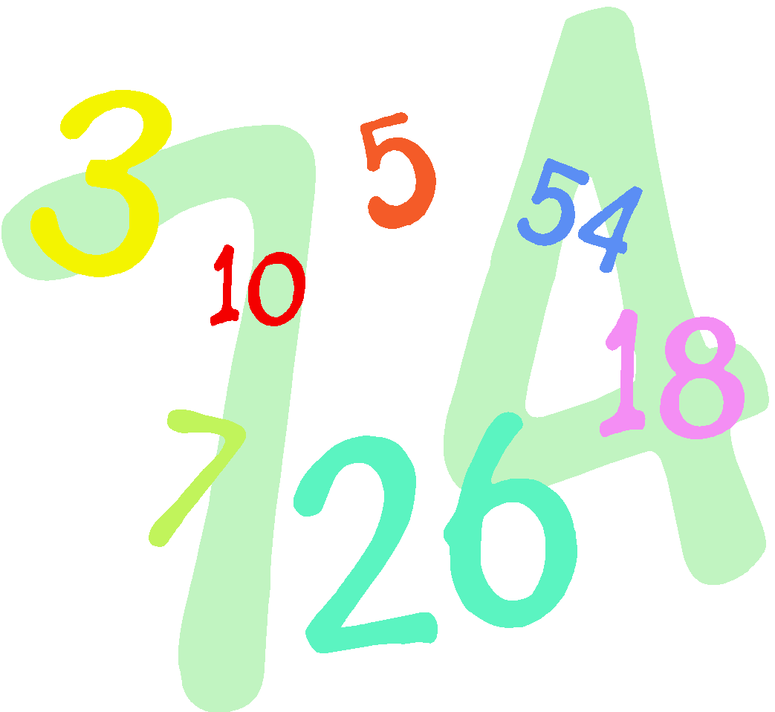

.

**Tuesday 11th March at 2.20pm**

Entrance will be through the nursery gate and then into the hall.

